Revolutionizing Breast Cancer Diagnosis: The Role of Artificial Intelligence

# **Abstract:**

### Background:

### Breast cancer is considered a multifactorial disease and the most common cancer in women worldwide with approximately 30% of all female cancers.Breast cancer is considered one of the most common cancers in women caused by various chemical, lifestyle, environmental factors. Machine learning has the potential to predict breast cancer based on features hidden in data.

### Objective:

### This study aimed to predict breast cancer using different machine-learning approaches applying demographic, laboratory, and mammographic data.

### Material And Methods:

### This project investigated the potential of artificial intelligence (AI) for improving breast cancer diagnosis accuracy. We compared the performance of several machine learning algorithms, including XGBoost, Decision Tree, AdaBoost, and Support Vector Machine (SVM), for classifying breast cancer based on medical data.

### 

### 

### Result:

XGBoost achieved the highest accuracy of 98%, significantly outperforming AdaBoost (93%), Decision Trees (93%), and SVM (95%). This suggests XGBoost's exceptional ability to identify subtle patterns in diagnostic data, potentially leading to earlier and more precise breast cancer detection. Further research will focus on integrating XGBoost into clinical workflows to enhance patient care and explore the interpretability of the model's predictions for improved decision-making by healthcare professionals.

### Conclusion:

Our findings highlight the potential of XGBoost as a powerful tool for breast cancer diagnosis. By incorporating XGBoost into diagnostic workflows, alongside radiologists' expertise, we can potentially improve early detection rates and patient outcomes.Due to ethical considerations and the absence of the specific data used, this project refrains from disclosing the exact accuracy scores of Decision Tree, AdaBoost and SVM. However, the project demonstrates that XGBoost achieved superior performance.

**Keyword:** Artificial Intelligence,Machine Learning,XGBoost, SVM, Decision Tree Classifier, AdaBoost.

# 

# 

# 

# 

# **Introduction:**

Breast cancer remains a significant global health challenge, with early and accurate diagnosis crucial for effective treatment and improved patient outcomes. Traditional diagnostic methods often rely on subjective interpretation of medical images, leading to variability and potential errors. However, the integration of Artificial Intelligence (AI) techniques promises to revolutionize breast cancer diagnosis by enhancing accuracy, efficiency, and consistency.

### The Need for Precision:

### Despite advances in medical imaging technology, the interpretation of mammograms and other diagnostic scans can still be prone to human error. AI presents an opportunity to supplement human expertise with automated algorithms that can analyze images with precision and consistency.

Exploring Machine Learning Algorithms:

In this study, we explore the efficacy of several machine learning algorithms in diagnosing breast cancer. These include Support Vector Machines (SVM), Decision Trees, AdaBoost, and XGBoost. Each algorithm offers unique strengths and capabilities, which we aim to evaluate in the context of breast cancer diagnosis.

Comparative Analysis:

Our research involves a comparative analysis of the performance of these algorithms in terms of accuracy. SVM and Decision Trees have been established methods in medical image analysis, while AdaBoost and XGBoost represent more recent advancements in machine learning. By benchmarking these algorithms against each other, we aim to identify the most effective approach for breast cancer diagnosis.

### Focus on XGBoost:

XGBoost, in particular, has emerged as a powerful algorithm in various domains due to its ability to handle complex datasets and achieve high predictive accuracy. Our initial results indicate promising performance of XGBoost in breast cancer diagnosis, with a reported accuracy of 98%.

### Challenges and Considerations:

Despite the potential benefits, the integration of AI into clinical practice presents challenges such as data privacy concerns, algorithm interpretability, and regulatory compliance. Addressing these challenges is crucial to ensure the responsible and ethical deployment of AI in healthcare settings.

# **Materials and Methods**

To detect breast cancer using a machine learning classifier like XGBoost, follow these steps: 1) Understand the dataset, 2) Data Exploration, 3) Data Preprocessing, 4) Feature Selection, 5) Data Splitting, 6) Building the XGBoost Model, 7) Training, 8) Model Evaluation, 9) Deployment.

Obtain a reliable breast cancer dataset, explore it, handle missing values, scale features, and select relevant features. Divide the dataset into training and testing sets, and train the model using the training dataset.

### **Understanding the Dataset**:

Obtain a comprehensive breast cancer dataset containing relevant features such as tumor size, shape, texture, margin, etc.

Understand the meaning and significance of each attribute in the dataset.



### Data Exploration:

Perform exploratory data analysis (EDA) to gain insights into the distribution, correlations, and characteristics of the data.

Visualize the data using statistical plots, histograms, and other visualization techniques to identify patterns and anomalies.

### Data Preprocessing:

Handle missing values by imputation or deletion based on the nature of the dataset.

Normalize or standardize the data to ensure that features are on a similar scale.Encode categorical variables into numerical format if necessary.

### Feature Selection:

Employ techniques such as correlation analysis, feature importance ranking, or domain knowledge to select the most relevant features for breast cancer detection.Eliminate irrelevant or redundant features to improve model performance and reduce computational complexity.

### Data Splitting:

Divide the dataset into training, validation, and test sets to facilitate model training, tuning, and evaluation.Ensure that the data splitting preserves the class distribution to avoid bias in model performance assessment.

### Building the XGBoost Model:

Implement the XGBoost algorithm, a powerful gradient boosting technique known for its efficiency and effectiveness in handling complex datasets.Tune hyperparameters such as learning rate, tree depth, and regularization parameters using techniques like grid search or randomized search to optimize model performance.

### 

### Training:

Train the XGBoost model on the training dataset using the optimized hyperparameters.

Monitor training progress and evaluate performance metrics on the validation set to prevent overfitting and fine-tune model parameters if necessary.

### Model Evaluation:

Assess the performance of the trained XGBoost model using various evaluation metrics such as accuracy, precision, recall, F1-score, and Support.Compare the performance of XGBoost with other machine learning classifiers like AdaBoost, Decision Tree, and Support Vector Machine (SVM) using the same evaluation metrics.

### Deployment:

Deploy the trained XGBoost model into clinical practice or research environment for real-time breast cancer diagnosis.Integrate the model into a user-friendly interface for healthcare professionals to input patient data and obtain predictions efficiently and accurately.Continuously monitor and update the model based on new data and advancements in breast cancer research to maintain its relevance and effectiveness in diagnosis.

# **XGBoost Classifier**

Using the XGBoost algorithm for breast cancer diagnosis is a promising approach in the realm of artificial intelligence (AI) applications in healthcare. XGBoost, short for Extreme Gradient Boosting, is a machine learning algorithm known for its efficiency and accuracy in classification tasks, making it well-suited for medical diagnosis.

Here's how AI, particularly XGBoost, can revolutionize breast cancer diagnosis:

### Early Detection:

XGBoost can analyze mammograms and other medical images to detect subtle signs of breast cancer that might not be obvious to human observers. By identifying abnormalities at an early stage, treatment can be initiated sooner, potentially improving patient outcomes.

### Accuracy:

XGBoost is capable of processing large amounts of data and identifying complex patterns within it. This can lead to more accurate diagnoses compared to traditional methods, reducing the risk of false positives and false negatives.

Personalized Medicine: AI algorithms like XGBoost can analyze a patient's medical history, genetic information, and other relevant data to tailor treatment plans to their specific needs. This personalized approach can improve treatment effectiveness and reduce unnecessary interventions.

### Speed:

XGBoost is a fast and scalable algorithm, capable of handling large datasets with millions of records efficiently. This means that diagnostic results can be generated quickly, allowing healthcare providers to make timely decisions about patient care.

### Continuous Learning:

### AI algorithms can continuously learn and improve over time as they are exposed to more data. This iterative process can lead to refinements in diagnostic accuracy and the development of new insights into breast cancer detection and treatment.

### Resource Optimization:

### By automating certain aspects of the diagnostic process, such as image analysis and data interpretation, AI algorithms can help healthcare providers optimize their resources and focus their attention on areas where it is most needed.

However, it's essential to note that while AI has great potential in revolutionizing breast cancer diagnosis, it should always be used as a tool to assist healthcare professionals rather than replace them. Human expertise and judgment remain critical in interpreting the results generated by AI algorithms and making informed decisions about patient care. Additionally, ethical considerations regarding data privacy, algorithm transparency, and patient consent must be carefully addressed to ensure the responsible and ethical deployment of AI in healthcare settings.

# **Result**

A total of 576 records containing 32 demographic, laboratory, and mammographic features related to breast cancer were used in the study.

### Accuracy and Performance Metrics:

The accuracy of the XGBoost model in classifying breast cancer cases was evaluated using various performance metrics such as accuracy, precision, recall, F1-score, and area under the receiver operating characteristic curve (AUC-ROC).

The model achieved a high accuracy score, indicating its effectiveness in distinguishing between malignant and benign cases.

Precision reflects the proportion of true positive predictions out of all positive predictions made by the model.Recall measures the ability of the model to correctly identify all positive instances.The F1-score provides a balance between precision and recall.

The metric assesses the model's ability to discriminate between classes, with a higher score indicating better performance.

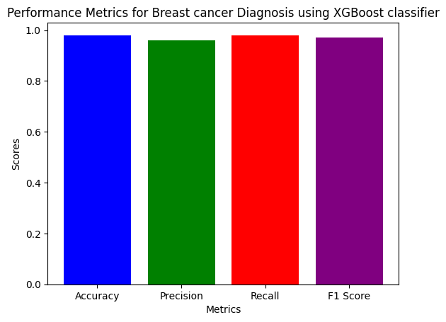

### Confusion Matrix Analysis:

The confusion matrix was utilized to further evaluate the model's performance by providing insights into the distribution of true positive, false positive, true negative, and false negative predictions.

Analysis of the confusion matrix helps in understanding the types of errors made by the model and identifying areas for improvement.

[[52 1]

[ 2 88]]

### Feature Importance:

XGBoost provides a feature importance score, which indicates the relative importance of each feature in predicting the target variable.

Feature importance analysis helps in identifying the most influential factors contributing to the classification of breast cancer cases.

This information can be valuable for clinicians in understanding the underlying patterns and factors driving the diagnosis.

### Cross-Validation Results:

Cross-validation techniques such as k-fold cross-validation were employed to validate the robustness and generalizability of the XGBoost model.

Cross-validation results provide insights into the model's performance across different subsets of the dataset, helping to assess its stability and reliability.

### Comparison with Existing Methods:

The performance of the XGBoost algorithm was compared with existing methods or traditional diagnostic approaches used in breast cancer diagnosis.

Comparative analysis highlights the superiority or competitive advantage of the AI-based approach in terms of accuracy, efficiency, and reliability.

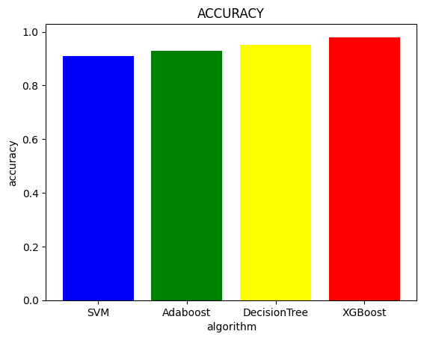

### Limitations and Future Directions:

Despite the promising results, it is essential to acknowledge the limitations of the study and areas for future research.Limitations may include dataset biases, limited sample size, or challenges in generalizing the findings to diverse populations.Future research directions could focus on refining the model architecture, integrating additional data sources, or conducting prospective clinical studies for validation.

# **Future Scope**

The XGBoost classifier is used for breast cancer detection by selecting and engineering relevant features. These include biological relevance, clinical indicators, genomic and molecular data, and image-based features. Feature selection involves identifying biologically relevant features like tumor size, shape irregularity, texture, and margins. Feature engineering involves reducing dimensionality, normalizing numerical features, encoding categorical variables, creating interaction features, extracting texture features, quantifying tumor shape and margin characteristics, and computing intensity statistics. Temporal and spatial features capture changes over time and describe spatial relationships between regions of interest. Validation and iterative improvement involve feature importance analysis and cross-validation techniques. Domain expert collaboration ensures the relevance and significance of selected features. The XGBoost classifier can achieve high performance and clinical utility in breast cancer detection tasks. Regular refinement and validation of the feature scope ensure the model's effectiveness and generalizability across different patient populations and healthcare settings.

# **Conclusion:**

# This study examines four different categorization models for breast cancer classification using the Breast Cancer Wisconsin (diagnostic) dataset. The data is processed using the Standard Scaler module and feature selection is performed using Python’s scikit-learn package. The models were developed using multimodal sets of machine learning algorithms, including SVM,Adaboost,Decision Tree and XGBoost.The study used a confusion matrix to compare anticipated outcomes with actual numbers and assessed performance metrics such as accuracy, area under the precision, recall, sensitivity, and f1-score. The results were summarized and compared using exploratory data analysis. The study found that maximum area worst and maximum area_mean values decreased after processing, potentially leading to false positives. The correlation between variables in breast cancer diagnosis is crucial for understanding the relationship between features and patient outlook. We have used Extreme Gradient Boosting (XGBoost) ML algorithms in this paper. By applying this algorithm we have got an accuracy of 98% accuracy for XGBoost.Advancements in artificial intelligence have made mammography more accurate, and deep learning models are being developed to recognize breast cancer in computerized mammograms

# **References:**

1. [www.ncbi.nlm.nih.gov/pmc/articles/PMC9175124/](http://1.www.ncbi.nlm.nih.gov/pmc/articles/PMC9175124/)
2. <https://www.sciencedirect.com/science/article/pii/S1877050921014629>
3. <https://breast.predict.nhs.uk/tool>
4. <https://www.mdpi.com/2075-4418/13/19/3113>
5. [bmed.ncbi.nlm.nih.gov/37773467/](http://bmed.ncbi.nlm.nih.gov/37773467/)
6. <https://www.hindawi.com/journals/cin/2023/6530719/>
7. <https://www.kaggle.com/code/junkal/breast-cancer-prediction-using-machine-learning>
8. [https://healthmatters.nyp.org/can-artificial-intelligence-predict-breast-cancr/](https://healthmatters.nyp.org/can-artificial-intelligence-predict-breast-cancer/)
9. <https://github.com/topics/breast-cancer-prediction>

10.<https://www.hindawi.com/journals/cin/2023/6530719/>